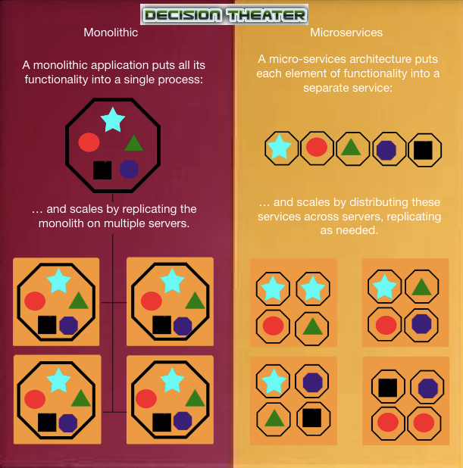

A monolithic architecture, that is built as a single unit, interconnects services and requires that each must be present on a server for the code to run. When a service is required in an application, each service connected must be added on the server as well. A microservice architecture allows each service to be independent and loosely coupled with others on a single server as needed. By using a microservice architecture in an application, a server can be placed in the application that encompasses any individual services required. If using a monolithic structure, each service must be run as a process. When an application needs to provide a service, the entire process must be run, requiring its own individual server to be added. If, for example, the application needs to show two different visuals, two new servers are required to run all services in order to access those visuals in the process. A microservice architecture ensures that each individual server added only needs to run required services rather than an entire process for one service. Unneeded services will not be forced to run in the process, requiring far fewer servers. An application that requires fewer servers will reduce costs in building and then managing the application in the future.

