Automated Landscape Classification

Contents
1 Introduction 2
2 eCognition 2
3 What is needed to run the script? 2
4 Results from running the script 2
4.1 Showing lakes 3
4.2 Showing vegetation 3
4.3 Shows pools 4
5 Ecognition Script 5
6 Appendix 6

Introduction
This document explains how eCognition was used to automate landscape classification and provides the script needed to do this.

eCognition
eCognition makes a radical departure from conventional approaches to data analysis due to its ability to emulate the human mind's cognitive powers and fuse geospatial input data. Using patented segmentation and classification processes, eCognition developed a robust method of rendering knowledge in a semantic network. The technology examines pixels/ points not in isolation, but in context. It builds up a picture iteratively, recognizing groups of pixels as objects. Just like the human mind, it uses the color, shape, texture and size of objects as well as their context and relationships to draw the same conclusions and inferences as an experienced analyst, but adding the advantages of automation and standardization. Though somewhat simplified, the following example illustrates the basic principles.

What is needed to run the script?
The following things are needed to run the script in Ecognition.
- Red Green Blue (RGB) image
- LIDAR Data (Light Detection and Ranging) (See appendix for point clouds)
- Infrared
Load the following datasets into Ecognition and run the script. It will output the surface area of the different types of landscapes.

Results from running the script
This shows an example output from a randomly ingested dataset.

Showing lakes
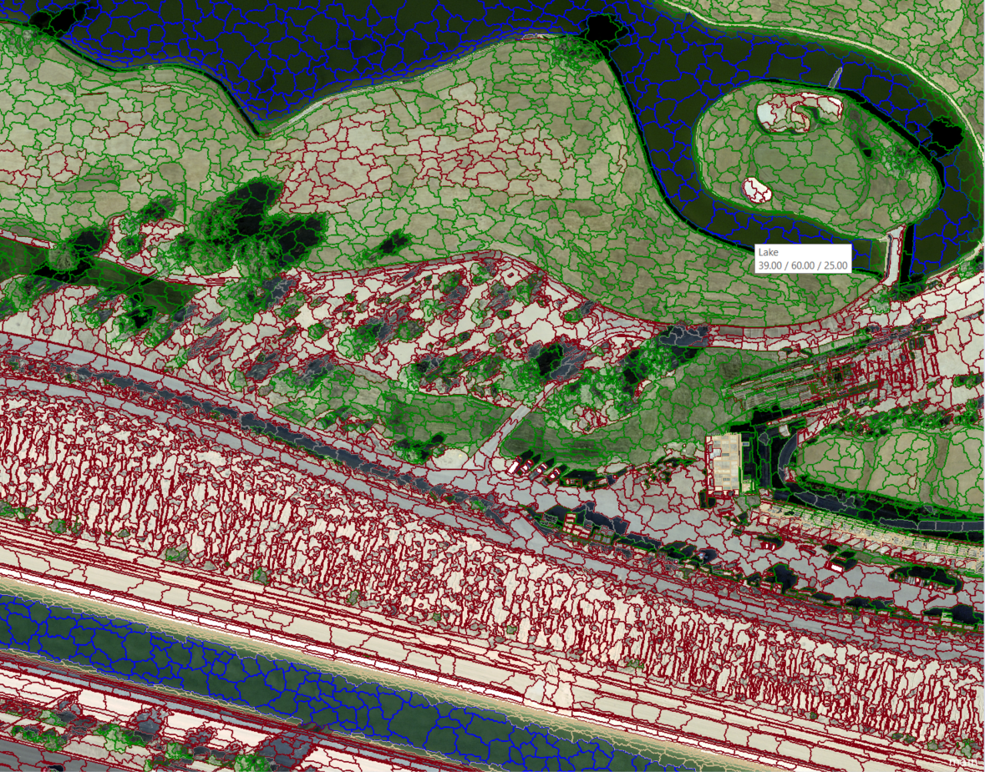

Showing vegetation
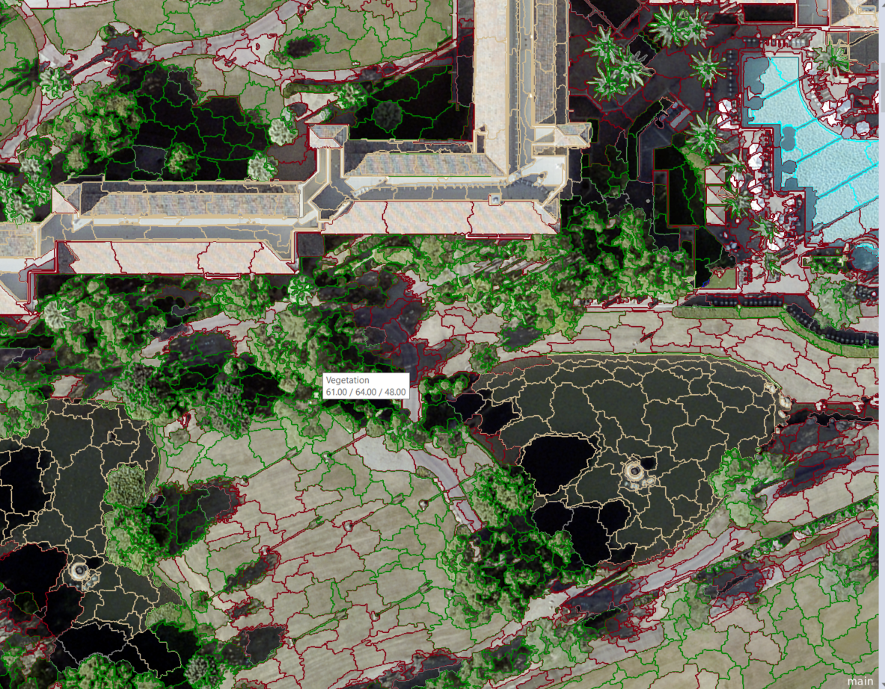

Shows pools
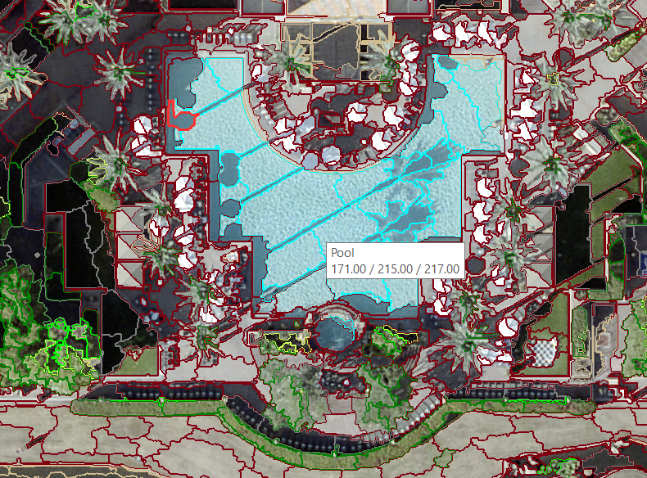

Ecognition Script

Please click on the following picture to get the Ecognition script. This contains 4,450 lines of code to create an automated repeatable identification process.

Appendix
If you have a rasterized point cloud you will have to convert it into a 2D raster layer for the script to work. You can do this by doing the below. It should be noted that Layer 5 in the image below is the unhandled LIDAR data. The below process takes the raw .las file and outputs an nDSM layer.
